GOOGLE CLOUD LAB

1. a. Execute a Python Program in Google Cloud Shell
Aim: Run a Python application using a cloud-based environment.
SNAP 1 -> GOOGLE CLOUD HOME PAGE
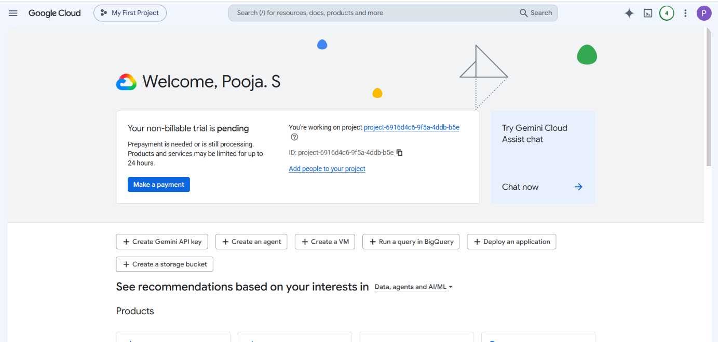

SNAP 2 -> AUTHORIZE CLOUD SHELL
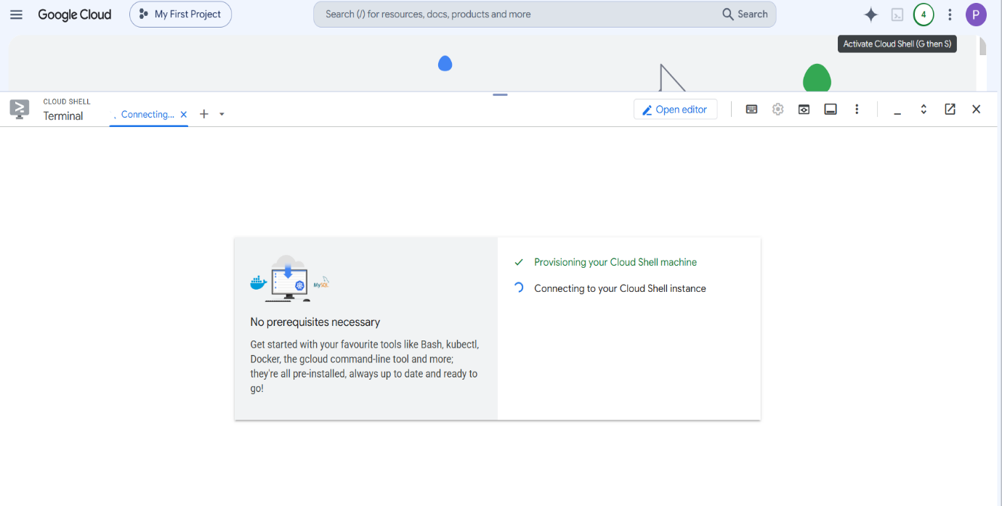

SNAP 3- > NANO HELLO.PY
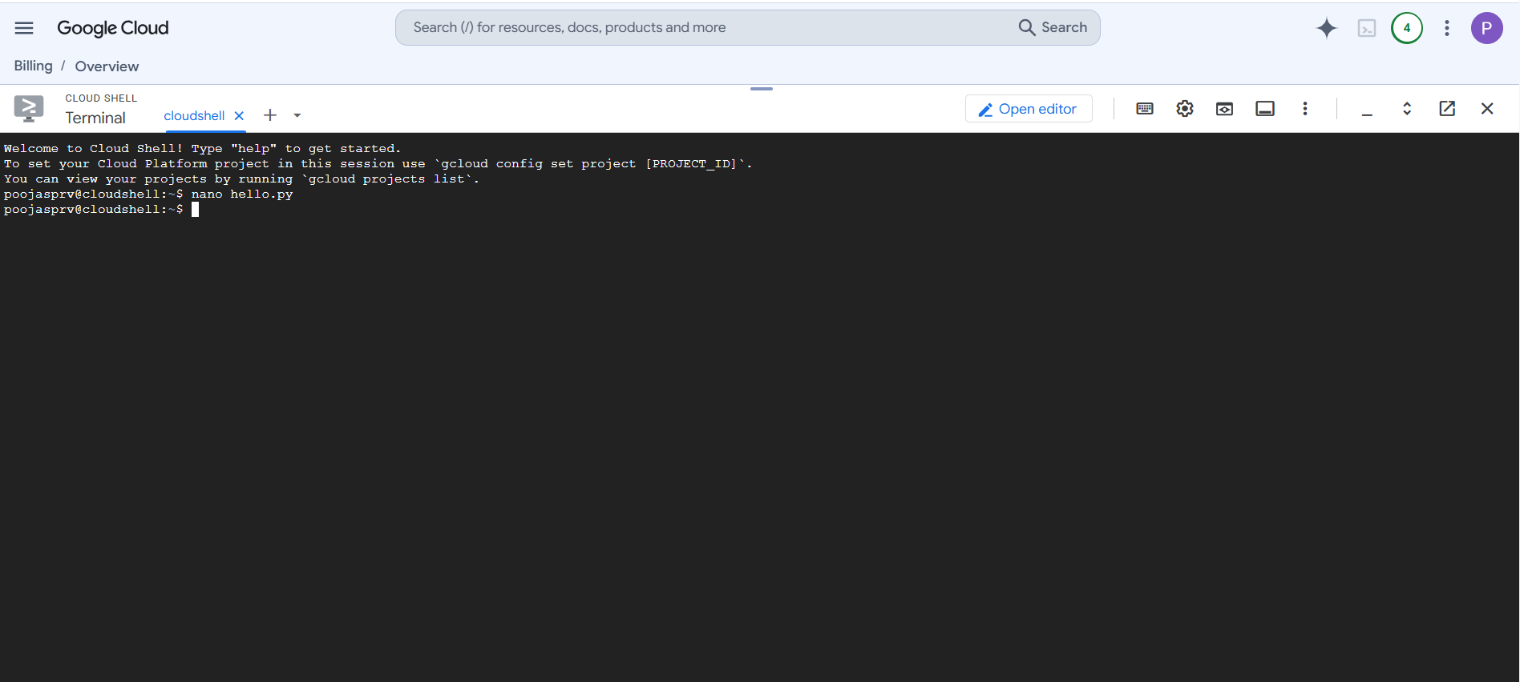
SNAP 4 -> PYTHON CODING
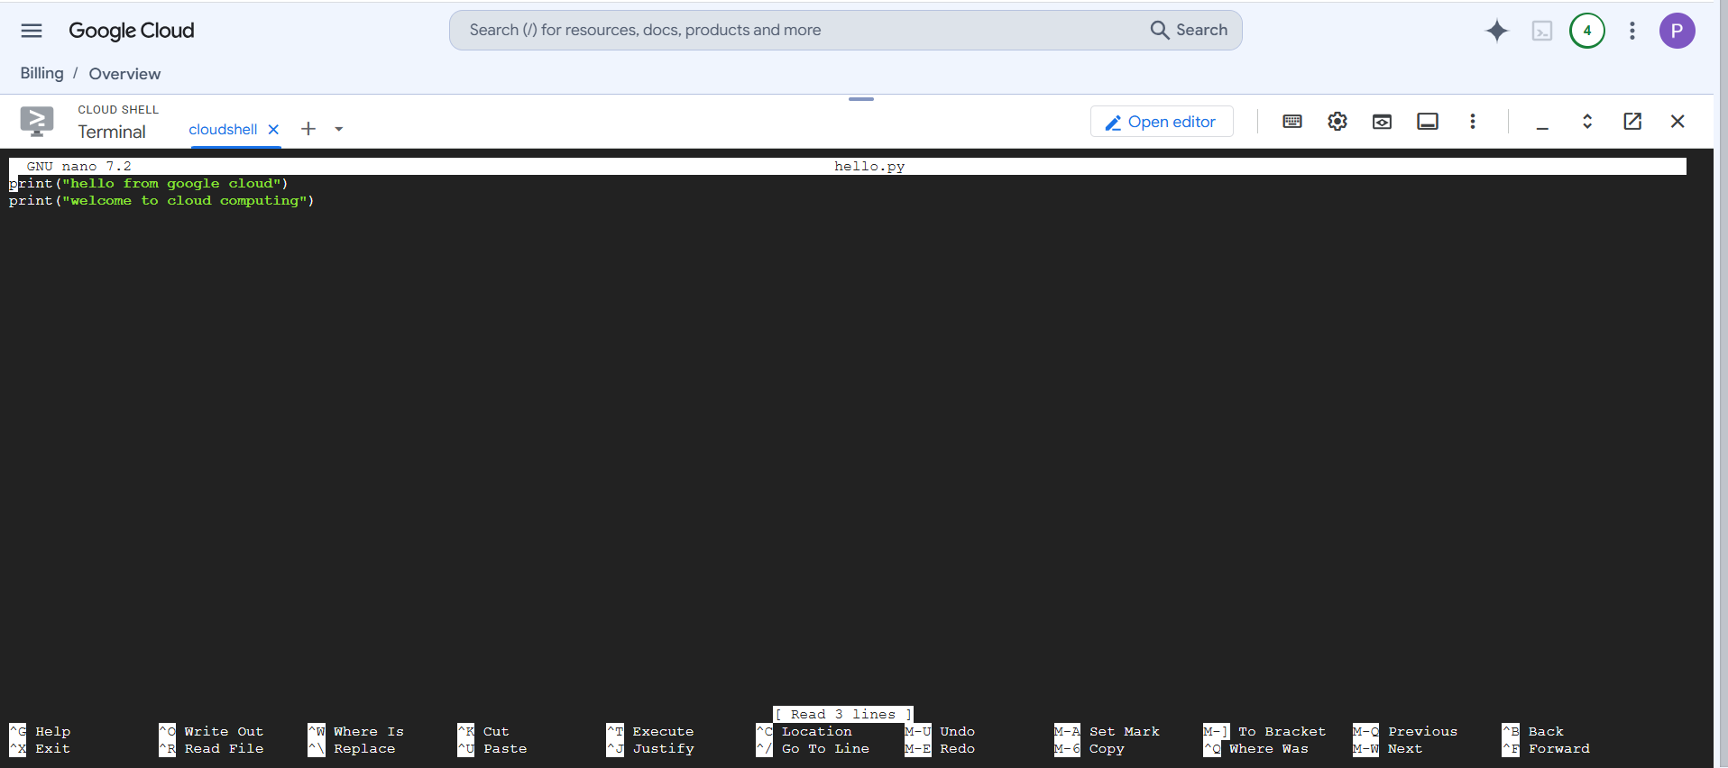
SNAP 5 -> EXECUTE & OUTPUT
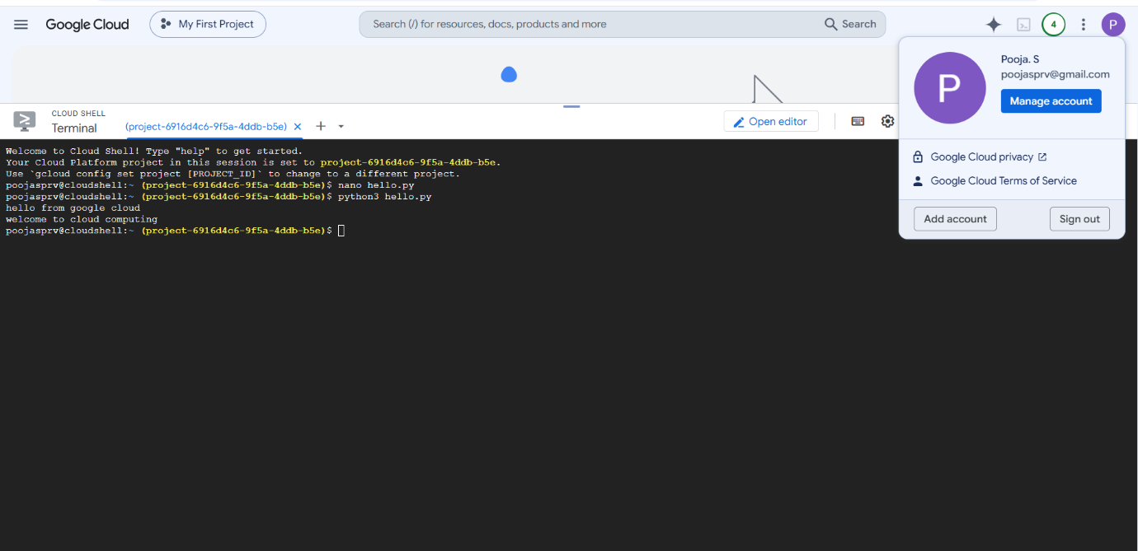
1.b Addition of two numbers using python in Google Cloud Shell
SNAP 1 -> PYTHON CODING
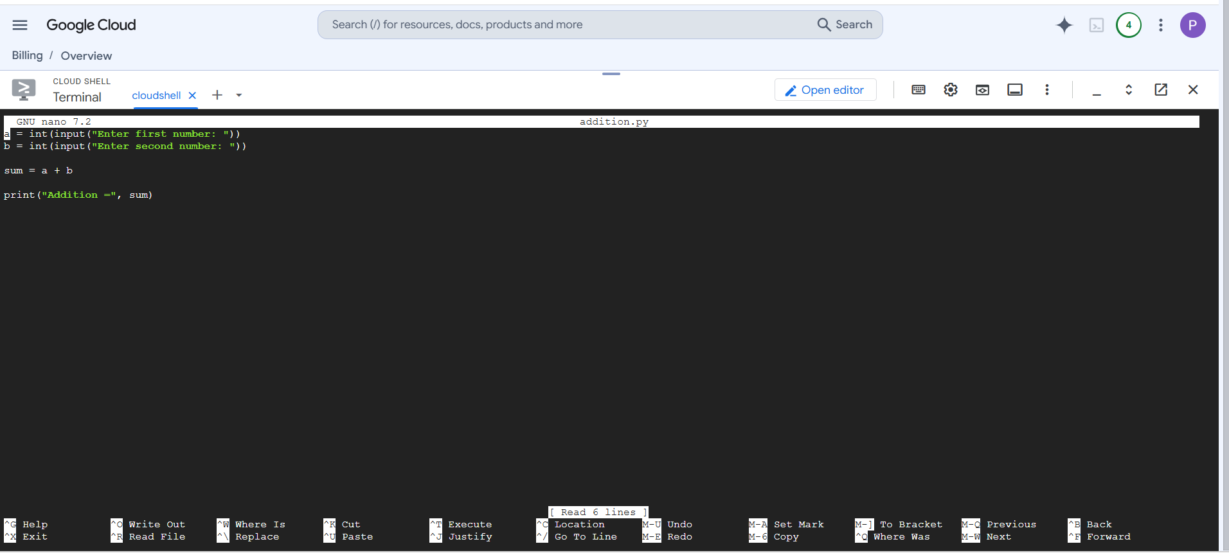
SNAP 2 -> EXECUTE & OUTPUT
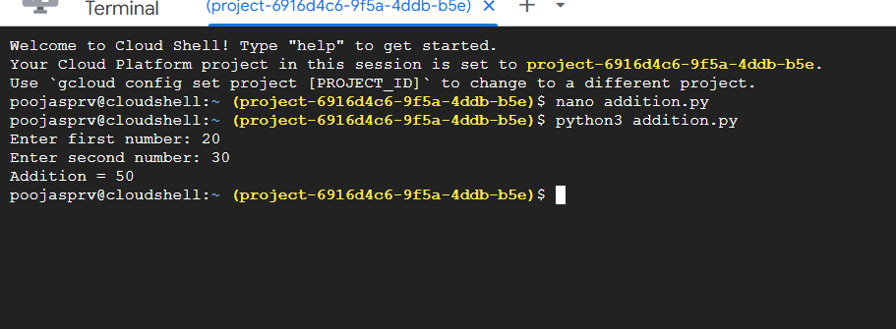

2. Create and Manage Files in Cloud Storage of Cloud Shell
Aim: Demonstrate cloud-based file creation and management.
SNAP 1 -> EXECUTE ALL COMMANDS AND GET OUTPUT
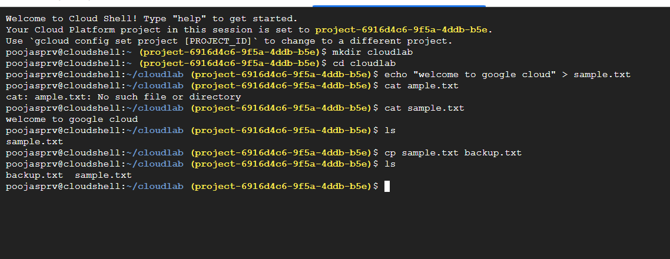

3. Run a Simple Web Server in Google Cloud Shell
Aim: Host and access a simple webpage from a cloud development environment.
SNAP 1 -> NANO -> HTML FILE
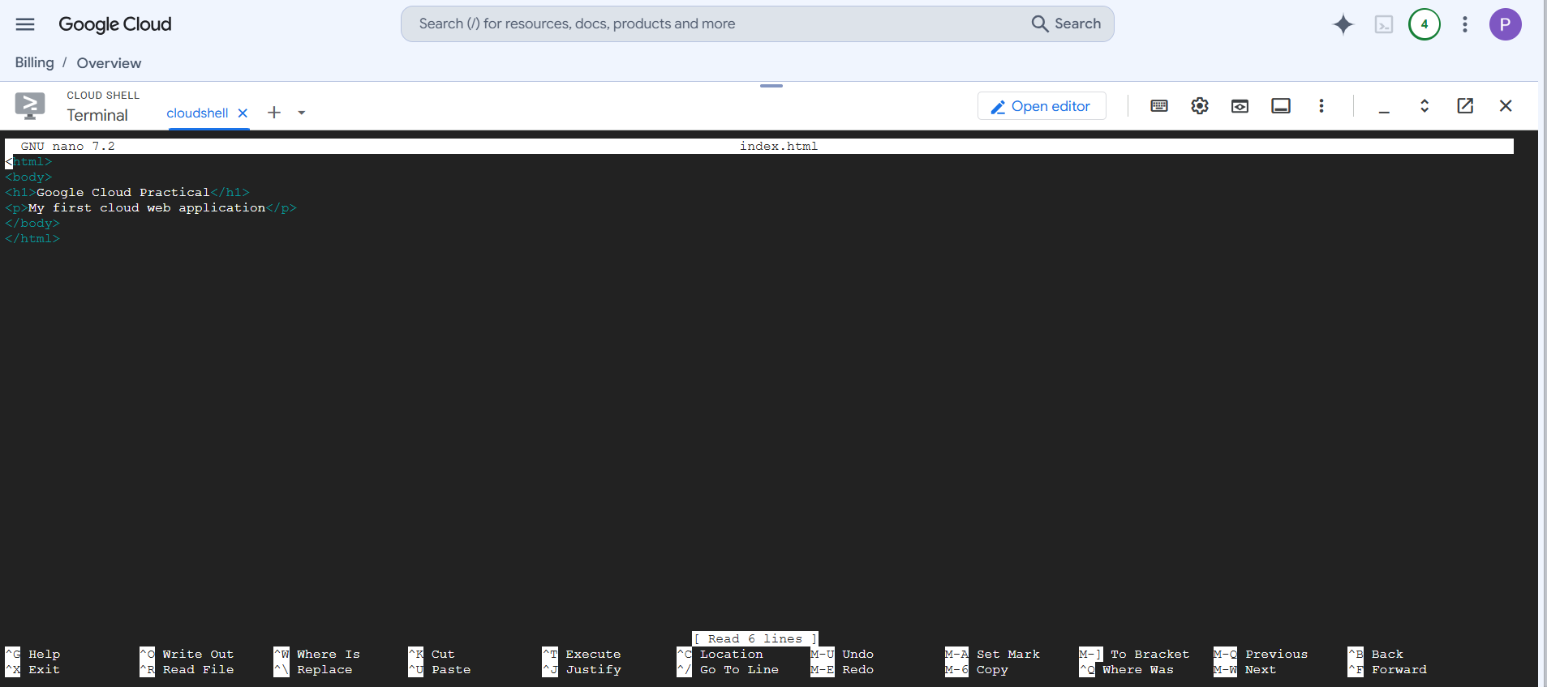
SNAP 2 -> WEB PREVIEW
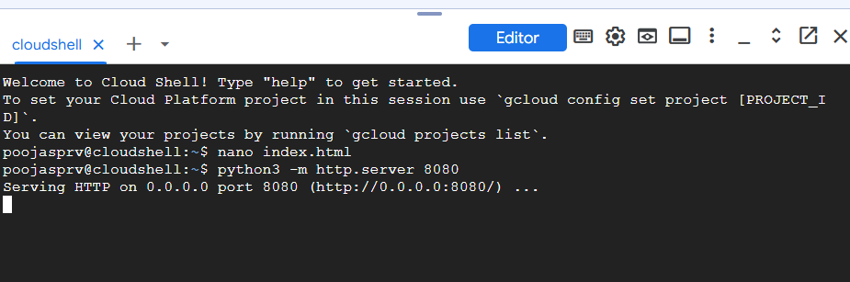

SNAP 3 -> OUTPUT (WEB PAGE DISPLAY)
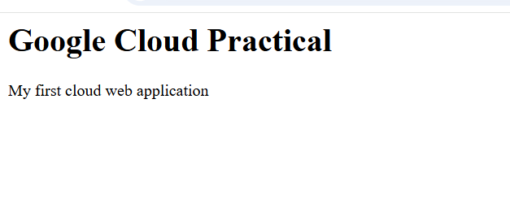
4. System Resource Monitoring in Google Cloud Shell
Aim: Demonstrate monitoring of CPU, memory and storage resources in a cloud environment.
SNAP -> ALL COMMANDS OUTPUT
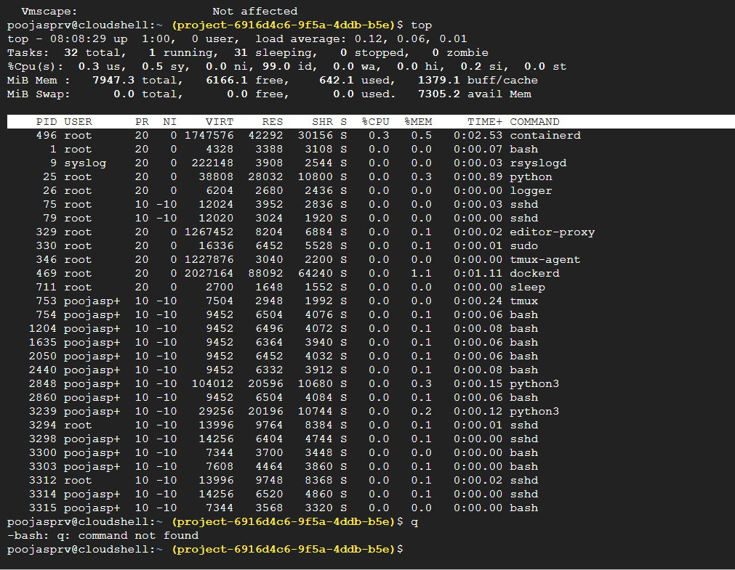

5. Execute a C Program in Google Cloud Shell
Aim: Compile and execute a C application in a cloud-based environment.
Create program:
SNAP 1 -> C CODING
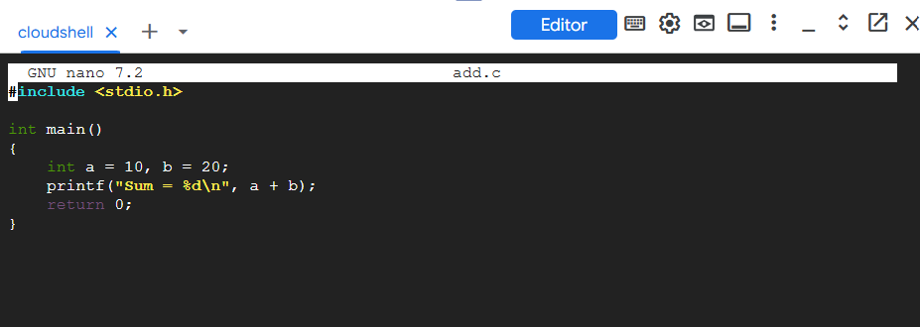
SNAP 2 -> EXECUTE & OUTPUT
